Compare different machine learning models to forecast rainfall in the Hanoi area
Dong Ngoc Gia Bao, Nguyen Duc Nhat,
Tran Quang Vinh, Dinh Gia Bao, Tran Hoang Anh
Khoa Trí tuệ nhân tạo, FPT University, Hanoi, Vietnam
baodnghe181000@fpt.edu.vn, qvinh0073@gmail.com, baokenwolf@gmail.com, jeffnhat@gmail.com,
trinhptthe160790@fpt.edu.vn

Abstract: Accurate rainfall forecasting is essential in urban planning, agriculture and disaster management. And there are many machine learning models. So we want to compare and evaluate the most accurate machine learning models that we refer to including XGBoost, CatBoost, ElasticNet, Random Forest(RF) when running on Hanoi rainfall data. The models were trained and tested on re-analysis data from the ERA5 dataset, specifically hourly data on single levels aggregated into monthly average values. The model accuracy was evaluated by MAE, RMSE and R^2. The experimental results demonstrate that all models achieve MAE and RMSE values less than 1, R^2 greater than 0.1 and the best performing model is XGBoost. Based on these observations, we propose potential improvements to improve the model accuracy. This study demonstrates the usefulness of machine learning algorithms in regional rainfall forecasting and serves as a comparative basis for future studies.

Keywords: Rainfall Prediction systems, Machine Learning, Rain dataset, prediction algorithms..

1. Introduction
There are many machine learning models for predicting rainfall, but which model will be the best and which model will perform best on rainfall data from Vietnam - a country with a tropical monsoon climate. For the climate in Vietnam, we first assume that machine learning models will be more difficult to predict accurately, because of the characteristic erratic rainfall. Numerical weather forecasts based on conventional physics and classical statistical models still have difficulty describing localized extreme rainfall events because they are based on ideal assumptions and require detailed gridded atmospheric data, which are often not available at high temporal resolution for Vietnam.
Recent advances in artificial intelligence (AI) provide an alternative path. Machine learning (ML) algorithms can learn the non-linear relationships between atmospheric variables—temperature, humidity, surface pressure, wind speed, etc.—and cumulative rainfall, without explicitly modeling the physical processes. Although ML has been applied to meteorological problems worldwide, systematic evaluations for short-term rainfall forecasting in Southeast Asia are still scarce.
This study selected the best ML models for rainfall forecasting in Vietnam from the models we studied, such as ML—Random Forest, Gradient Boosting (XGBoost and CatBoost), and the baseline ElasticNet model, to forecast rainfall one month ahead for the Hanoi region. The models were trained and evaluated on hourly detailed ERA5 reanalysis data compiled from 2016 to 2024. We also tested the data with granularity of features. Performance was quantified primarily by Mean Absolute Error (MAE), with additional metrics such as Root Mean Square Error (RMSE) and Coefficient of Determination (R^2).
By identifying the most appropriate model for Vietnam’s dominant monsoon climate, we aim to provide a practical decision support tool for farmers and disaster management agencies, and to make our research publicly available for future research groups working on rainfall forecasting, as most of the sources we found do not provide open source code.

2. Dataset and preprocessing
As for the data, we collected it from ERA5 - a reputable source of weather data. And in order for us to fully understand how the model will use the data, how to build the model, what the characteristics of the data are, and how to optimize and improve the model. We had to start with analyzing the data we had collected.
This report summarizes the analysis of hourly rainfall data recorded from January 1, 2016, to December 31, 2024, by an automatic weather station in Hanoi. The dataset includes 78,912 clean, validated records, each containing the time of observation (valid_time) and the rainfall amount in millimeters (rain_mm).

Preprocessing involved converting timestamps, setting time as index, and verifying data quality. No missing or invalid values were found. All rainfall values were within acceptable limits, and no extreme outliers (>50 mm/hour) were detected

Descriptive statistics show that rainfall is rare: over 90% of hours had less than 0.001 mm of rain, and more than half had no rain at all. The maximum observed rate was about 15 mm/hour. The rainfall distribution is highly skewed toward zero, with a long tail representing occasional heavy rain.

Seasonal trends are clear. Rainfall peaks between June and August, especially in July, while January and February are almost entirely dry. Monthly averages and boxplots confirm that July consistently records the highest rainfall and most outliers, indicating frequent intense storms. Annual totals also vary significantly year to year.

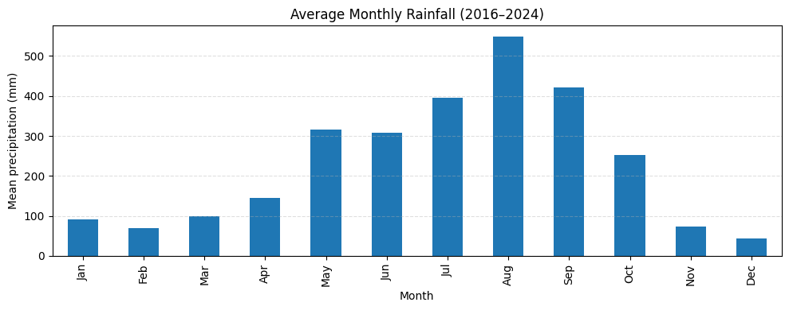

Figure 1. Average Monthly Rainfall (2016-2024)

In conclusion, Hanoi’s rainfall shows strong seasonality, dominated by a short but intense wet season. Although most of the year is dry, the presence of sporadic heavy rainfall events highlights the need for preparedness in urban planning and climate adaptation.

3. Predictive model
We have studied about 10 commonly used machine learning algorithms for rainfall forecasting, and finally we have selected 3 models that have the highest potential and accuracy in the previous research papers. So we have run those 3 models on our data, which are 3 models CatBoost, Random Forest, XGBoost and 1 basic model which is Linear Regression. And finally these models perform quite well on our data set.

3.1 XGBoost
The first model we decided to run on the Hanoi rainfall dataset is XGBoost - a powerful and well-known model in the field of prediction and classification.
We have developed the XGBoost model with the Train set being the first 7 years (2016 - 2022) and the Test set being 2023 and 2024. Our goal for this model is that the MAE and RMSE should be less than 0.4, while the R^2 should be around 0.8. And we actually achieved our goal.

3.1.1 Predicted Results for 2023

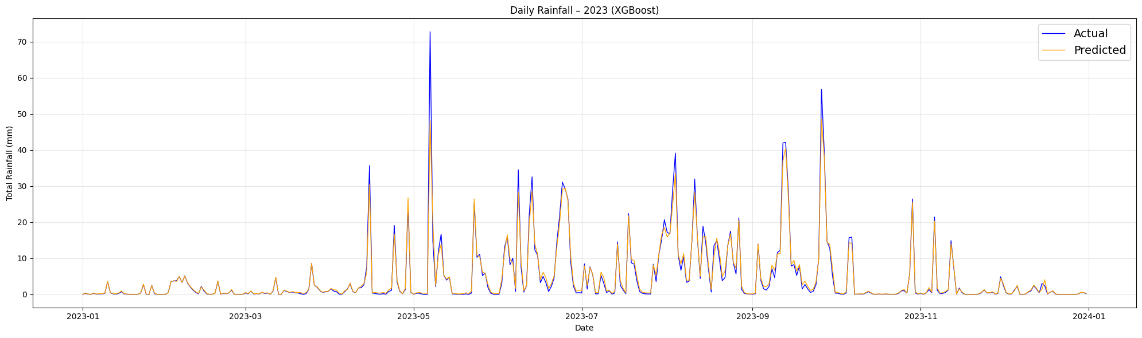
Figure. 5. Comparison Chart: Predicted vs. Actual Values in 2023

For 2023, the model is quite accurate with MAE = 0.25927, RMSE = 0.0809, R^2 = 0.7962. The above numbers show that the model is mostly accurate, but cannot predict the month with unusually high rainfall.

3.1.2 Predicted Results for 2024

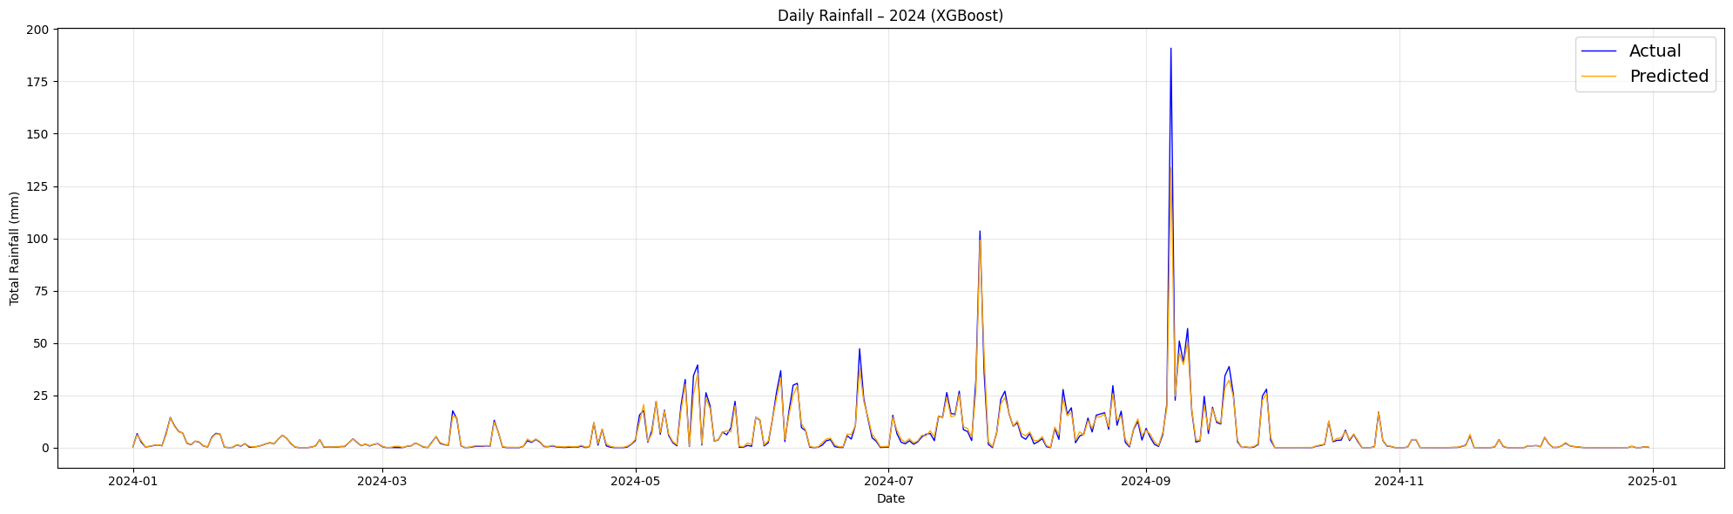
Figure. 6. Comparison Chart: Predicted vs. Actual Values in 2024

For 2024, the Model predicts quite accurately with MAE = 0.34197, RMSE = 0.10653, R² = 0.8086. These numbers further show that the model only predicts that the abnormal rainfall is unpredictable, the difference is due to the 2024 yagi storm. This further shows that the data from Vietnam is more unpredictable than other countries

3.2 CatBoost
Gradient Boosting Decision Trees (GBDT) are one of the most powerful tools for modeling structured data since they can learn non-linear dependencies and handle imbalanced data easily. Of the GBDT implementations, CatBoost—developed by Yandex [1]—is unique in natively supporting categorical features, employing Ordered Boosting to combat overfitting [2], and Symmetric Trees for training efficiency.CatBoost has demonstrated superior performance across a wide range of machine learning tasks, including time series forecasting and environmental modeling [3], in recent years. These capabilities make it very suitable for rainfall prediction problems, where the data contain both temporal dependencies and structured categorical features such as month and season.
Here, we apply CatBoost to predict Hanoi monthly rainfall quantities. We explore two modeling strategies: (1) Autoregressive prediction with a 3-month sliding window of past rainfall quantities, and (2) Calendar-based prediction with year and month as features.
The training and testing of the models follow the identical experimental protocol used with the other models in this study.

3.2.1 Model Setup
In the present study, monthly rainfall amounts over Hanoi were modeled using the CatBoost algorithm with ERA5 reanalysis data for the period 2016-2023. Two modeling settings were considered:
Autoregressive setup: A sliding window of three months of rainfall data (e.g., January–March) was used to predict the rainfall of the following month (e.g., April). This procedure was sequentially replicated for the entire calendar year, thus generating the forecasts.
Calendar-based setup: Temporal features such as month and year alone were used as predictors, with no past rainfall data fed into the model. In this way, the test becomes a measure of whether the model can learn seasonal regularities from calendar information alone.
Data was divided into training and testing sets (2016–2022 and 2023–2024, respectively). Regarding model evaluation criteria, three standard metrics of regression analysis were used: Mean Absolute Error (MAE), Root Mean Square Error (RMSE), and R-squared (R²) for a full picture of predictive accuracy and capacity to explain the variance.

3.2.2 Predicted Results and Evaluation
During testing the CatBoost model demonstrated excellent predictive strength to identify seasonal daily rainfall variations. Figure 12 reveals that the predicted rainfall matched observed data closely throughout both dry and wet seasons which shows the model's capability to handle complex precipitation patterns.The 2023 autoregressive model configuration used a sliding three-month sequence of past rainfall data to predict future values. The model achieved temporal dependency tracking through this configuration which generated precise high-resolution predictions that accurately captured rainfall event timing and intensity. The first plot in Figure 12 shows that CatBoost tracked most rainfall spikes during the year yet it slightly underestimated some peak magnitudes that occurred in May and September. The overall results stayed strong because the model achieved excellent accuracy in rainfall occurrence as well as distribution patterns.
The 2024 prediction model used the calendar-based approach which depended on month and year as input features alone. This setup generated generic seasonal patterns which did not use previous rainfall measurements. The model displayed reduced capability to detect unusual rainfall patterns since it underestimated specific rainfall peaks in July and September. The model demonstrated acceptable results in distinguishing wet from dry periods which makes it suitable as a basic cost-effective method when no historical data exists.
The CatBoost model demonstrated excellent performance across all evaluation metrics for both years. The model demonstrated strong prediction accuracy through its low MAE and RMSE values and R² scores reaching 0.79–0.78. CatBoost demonstrates reliable performance through its adaptable nature between data-rich autoregressive and data-sparse calendar-based test approaches. Figure 12 shows the daily rainfall comparisons which compare predicted values against observed values for both test years.
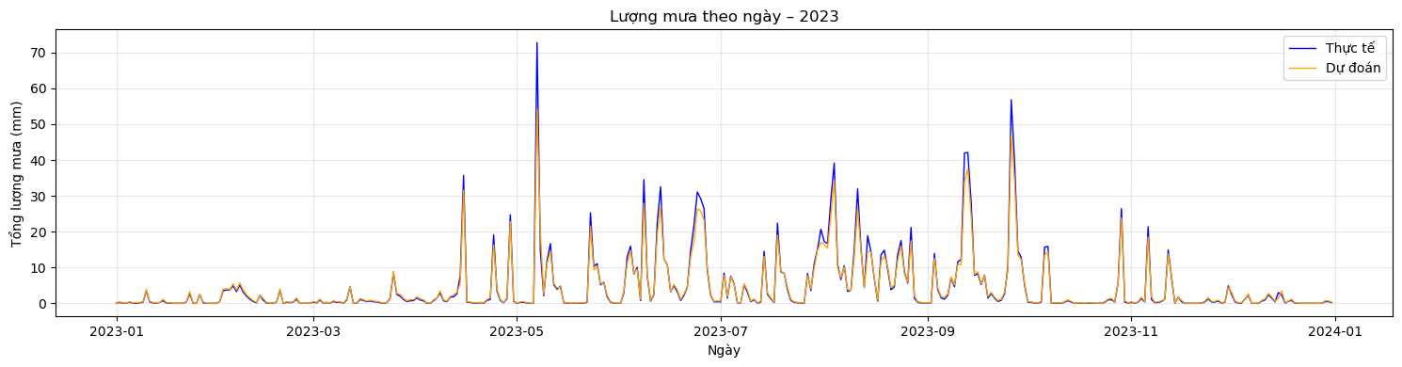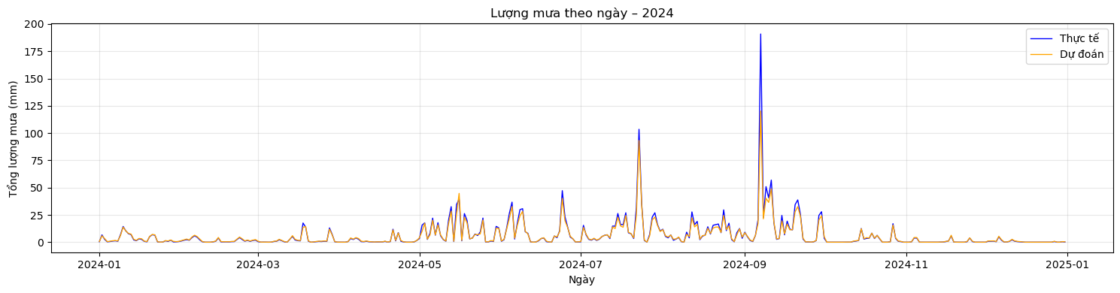
Figure 12. Comparison of predicted and actual daily rainfall in 2023 (top, autoregressive setup) and 2024 (bottom, calendar-based setup).

3.3 Elastic Net
ElasticNet is a regularized linear regression model including the strengths of both Lasso (L1) and Ridge (L2) penalties [4] in order to improve precision in predictions and feature selection stability, particularly in high-dimensional data. It was introduced by Zou and Hastie (2005), the method overcomes a disadvantage experienced when predictors are strongly correlated [5]—a common feature in meteorological data where many climate variables are connected.
In this study, we apply the ElasticNet regression model to forecast monthly rainfall in the Hanoi area using aggregated ERA5 reanalysis data. Given the sparse and highly skewed nature of rainfall data—where many months exhibit little to no precipitation while others experience heavy downpours—the ElasticNet model offers a promising balance between interpretability and robustness [6].
ElasticNet, unlike tree-based models, implies a linear relationship between input data and goal variables. However, by applying both L1 and L2 regularization simultaneously, it mitigates overfitting and enhances generalization performance [4]. This dual regularization also encourages sparsity, allowing the model to perform implicit feature selection by driving less informative coefficients to zero [5], while preserving groups of correlated features—a property known as the "grouping effect" [5].
We train the ElasticNet model using monthly rainfall features from 2016 to 2022 and evaluate its performance on the test set from 2023 to 2024. Hyperparameters such as the regularization strength (alpha) and mixing parameter (l1_ratio) are tuned via grid search cross-validation to achieve optimal forecasting accuracy [7].

3.3.1 Predicted Results for 2023
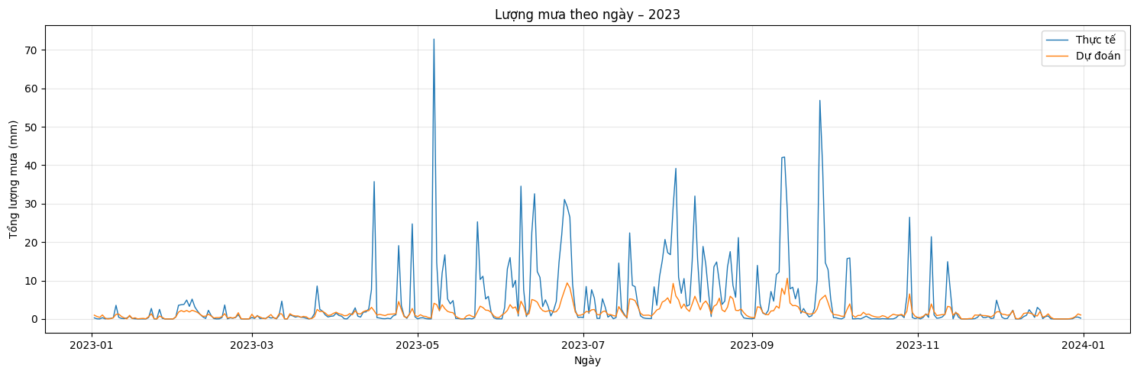
Figure 13. Comparison Chart: Predicted vs. Actual Rainfall in 2023

For the year 2023, the ElasticNet model exhibited moderate predictive performance. The average daily rainfall prediction aligned with the general seasonal trend but consistently underestimated the magnitude of heavy rainfall events, particularly between May and September.
The model achieved a Mean Absolute Error (MAE) of 0.1241, Root Mean Squared Error (RMSE) of 0.3323, and an R² score of 0.2738. These results indicate a limited ability to explain the variance in daily rainfall totals, with the model capturing only basic fluctuations and failing to react effectively to extreme peaks.
Despite its simplicity and computational efficiency, ElasticNet struggled to model the highly non-linear and sparse nature of rainfall data in 2023. Its linear structure likely contributed to the underestimation during high-intensity storms, which are not well-represented by linear interactions among input features.

3.3.2 Predicted Results for 2024
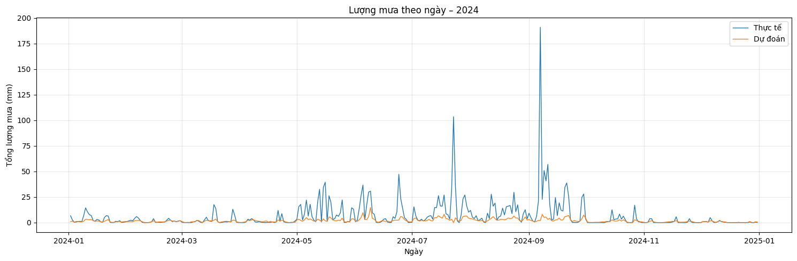
Figure 14. Comparison Chart: Predicted vs. Actual Rainfall in 2024

In 2024, the model's performance slightly declined compared to the previous year. The MAE increased to 0.1517, RMSE rose to 0.3867, and R² dropped to 0.1980, suggesting a further decrease in its ability to accurately predict daily rainfall totals.
As illustrated in the chart, the model continued to follow the overall shape of the rainfall seasonality but consistently lagged behind sharp spikes in precipitation. The mismatch is especially noticeable during the monsoon peak in September, where the model's forecast failed to approximate the intensity of actual events.
This underperformance reinforces the limitations of linear models like ElasticNet in capturing abrupt, high-variance phenomena common in tropical rainfall patterns. Nonetheless, the model retained some value in identifying general dry and wet periods, which could be useful in low-resource settings or as a baseline for more complex ensemble models.

3.4 Random Forest
Random Forest is a powerful ensemble learning method based on decision trees, widely used for regression and classification tasks due to its robustness, resistance to overfitting, and ability to handle noisy data. The model builds multiple decision trees and aggregates their outputs to improve predictive performance. Due to the randomness introduced in sample selection and feature splits, Random Forest effectively reduces variance and improves generalization.
In this study, we apply the Random Forest Regressor model to forecast hourly rainfall in Hanoi from 2016 to 2024. The input features include temporal attributes such as year, month, day, and hour, extracted from the valid_time timestamp column in the dataset. Model training and evaluation follow the same experimental protocol as used for other models in this study

3.4.1 Forecast Results for 2023
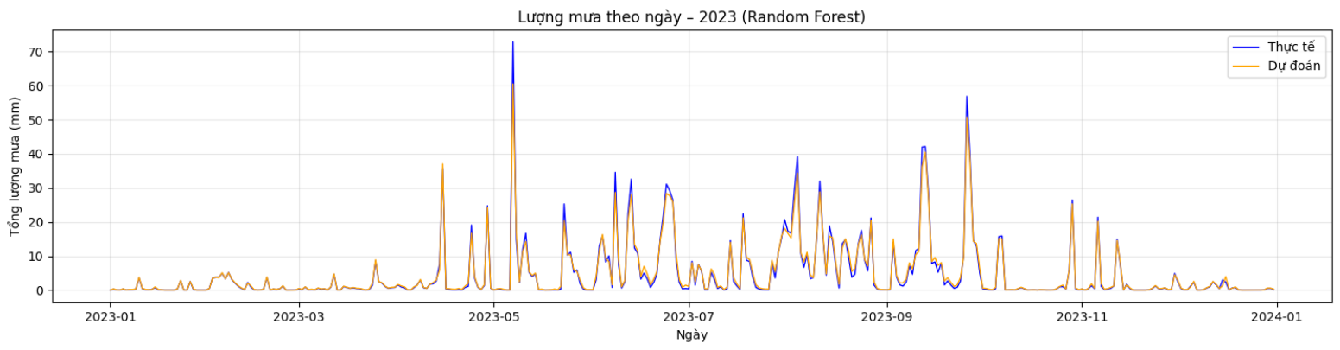
Figure 15. Rainfall Prediction vs Actual in 2023 using Random Forest

With Mean Absolute Error (MAE): 0.0794, Root Mean Squared Error (RMSE): 0.2563 and Coefficient of Determination (R²): 0.8009, these results indicate that the model captures daily rainfall patterns quite well. As observed from the chart, the predicted values closely follow the actual rainfall for most of the year, particularly during periods of moderate rainfall.
However, the model still struggles with predicting unusually high rainfall events, especially during the peak rainy season (May to October). This is a common limitation in many machine learning models, where rare or extreme events are underrepresented in the training data, causing the model to underpredict in such cases.
Despite this, the overall trend and intensity are effectively modeled, making Random Forest a reliable choice for forecasting in relatively stable weather conditions.

3.4.2 Forecast Results for 2024
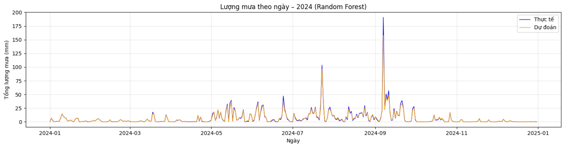
Figure 16. Rainfall Prediction vs Actual in 2024 using Random Forest
The results are: Mean Absolute Error (MAE): 0.1016, Root Mean Squared Error (RMSE): 0.2956 and Coefficient of Determination (R²): 0.8570
The relatively high R² value suggests that the model explains nearly 86% of the variance in rainfall, a strong indicator of performance. The MAE remains low, which implies that the model’s predictions are generally close to actual observations.
However, similar to 2023, the model underestimates the few but extreme rainfall spikes, particularly around September. These deviations are most likely caused by unexpected storm activity (e.g., tropical storm Yagi in 2024), which introduces a level of unpredictability that is hard to capture using only historical data.
Still, the prediction line follows the real trend quite smoothly, and the Random Forest model proves to be a robust and generalizable tool for daily rainfall forecasting in Vietnam.
Although the R² score was still relatively low, it was a notable improvement over the negative score obtained in the previous year, indicating that the model was able to explain a small portion of the variance in daily rainfall. The reduced error rates, particularly the RMSE, suggest that the model’s estimates were closer to the observed values on average.

4. Model comparison table
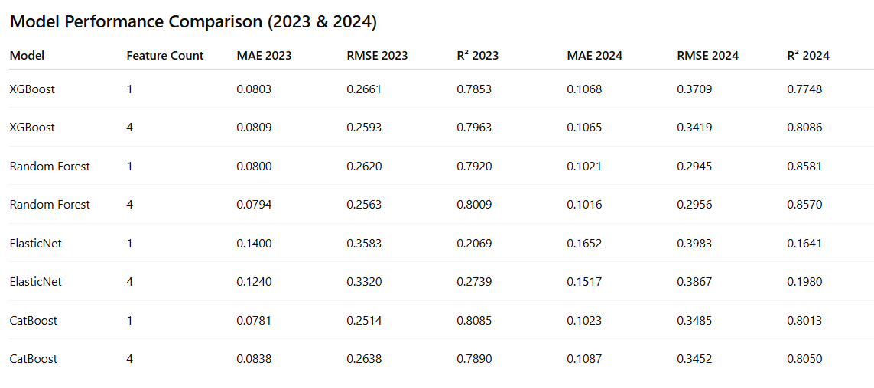
Figure 17. Model comparíon table in 2023, 2024

5. Conclusion
This study tested a total of 4 models on Vietnam's data and gave quite positive results. We also learned many lessons after testing. First, for Vietnam, with a tropical humid climate, evaluating and using machine learning models for prediction is more difficult. The evidence is that R^2 cannot approach 1 (0.99) but is lower (0.8).
Limitations from the models: lack of features, need to add more features to maximize model accuracy from which it is concluded that the model is also based on the integrity of the data, rainfall data still accounts for the most important part, the environment only adds a little accuracy, the evidence is that after adding environmental factors to the data, the accuracy of the model can be up to 0.5.
Evaluating the accuracy of models based on each MAE according to most open source codes on the network is not enough, it is necessary to evaluate many other factors to evaluate the accuracy of the model.
And the last, in the studies referenced, Catboost was found to be the most accurate predictor, but when run on Viet Nam data, RF was the most accurate predictor.

6. References
1. Prokhorenkova, L., Gusev, G., Vorobev, A., Dorogush, A.V., & Gulin, A. (2018). CatBoost: unbiased boosting with categorical features. arXiv preprint arXiv:1706.09516.
2. Dorogush, A.V., Ershov, V., & Gulin, A. (2018). Fighting biases with ordered boosting. Proceedings of the 35th International Conference on Machine Learning (ICML).
3. Liang, G., & Yu, X. (2020). Rainfall prediction based on CatBoost regression model. IOP Conf. Series: Earth and Environmental Science, 440, 032129.
4. Hastie, T., Tibshirani, R., & Friedman, J. (2009). The Elements of Statistical Learning: Data Mining, Inference, and Prediction. Springer.
5. Zou, H., & Hastie, T. (2005). Regularization and variable selection via the elastic net. Journal of the Royal Statistical Society: Series B (Statistical Methodology),67(2),301–320. https://doi.org/10.1111/j.1467-9868.2005.00503.x
6. Scikit-learndocumentationLinearModels:ElasticNet.https://scikit-learn.org/stable/modules/linear_model.html#elastic-net
7. Scikit-learndocumentation:https://scikit-learn.org/stable/modules/generated/sklearn.linear_model.ElasticNet.html
8. Scikit-learn documentation. Ensemble Methods: Random Forest Regressor https://scikit-learn.org/stable/modules/generated/sklearn.ensemble.RandomForestRegressor.html
9. ERA5hourlydataohttps://cds.climate.copernicus.eu/datasets/reanalysis-era5-single-levels?tab overview overviewn single levels from 1940 to present

